Assignment on

Internet Technologies

Assignment Weightage & Type

60% Portfolio Coursework

Corse: BSc (Hons) CS & DF

Sem_2

UWE ID: 24030171

Student Name: MD Faisal

Assignment Date: Week_3

Git Downloaded.

Git Installed.

L3 Folder created and extract with Git Bash Here we can see this screen

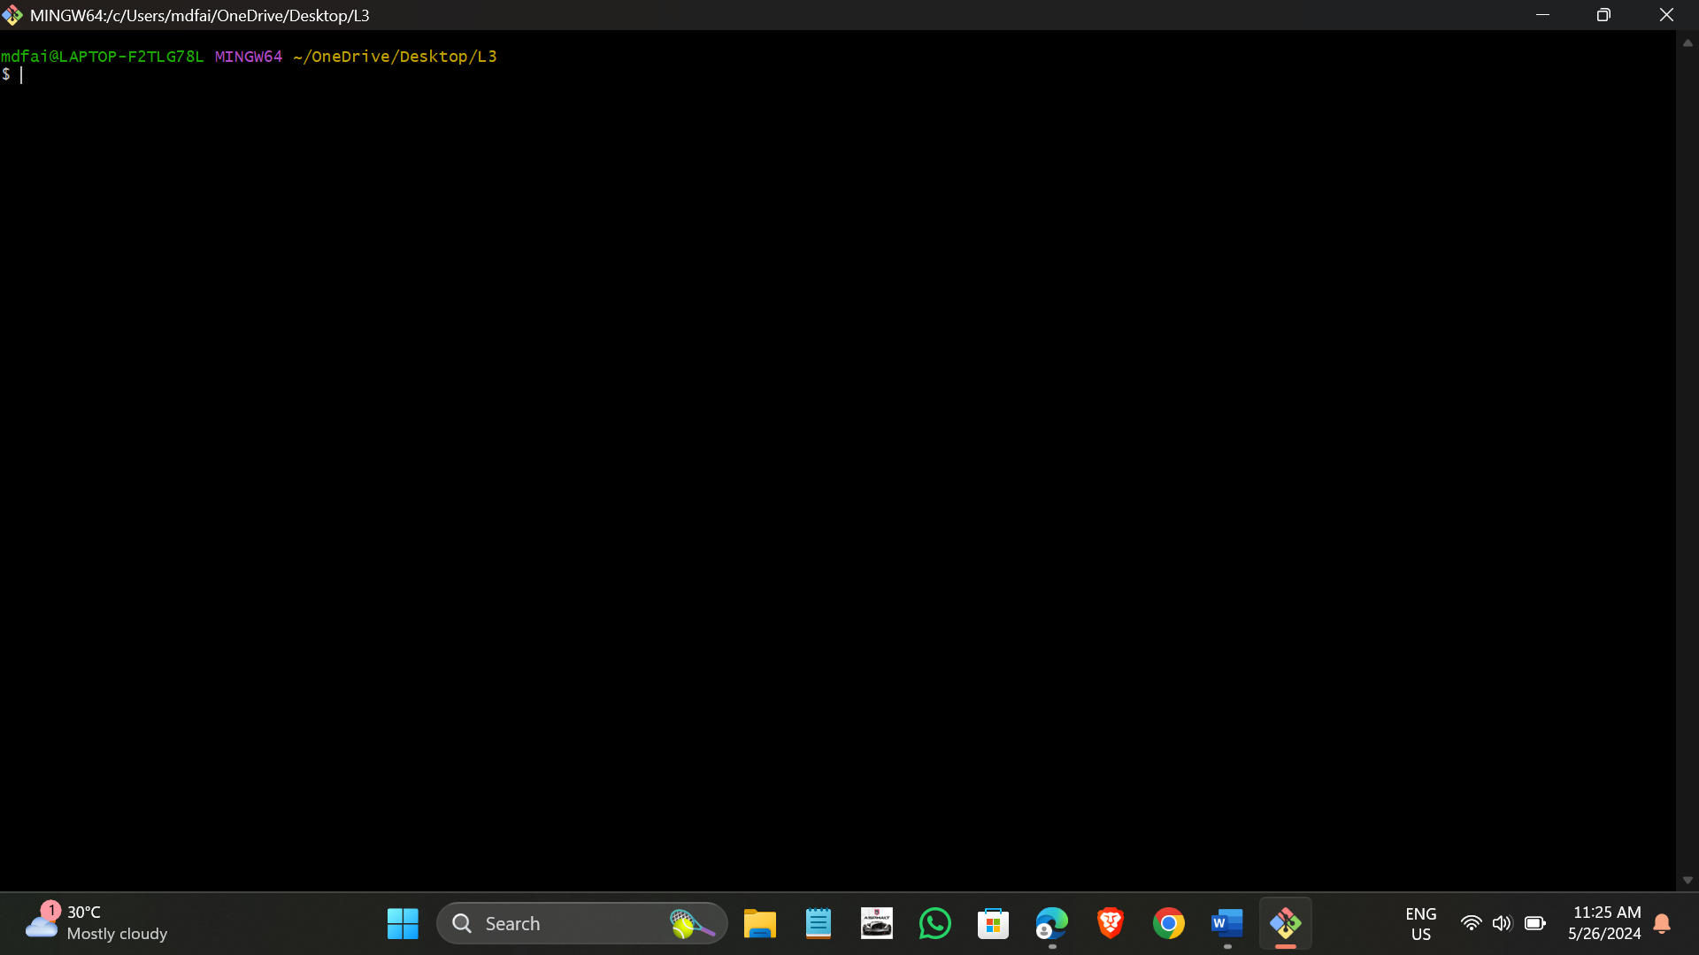

git –version checked

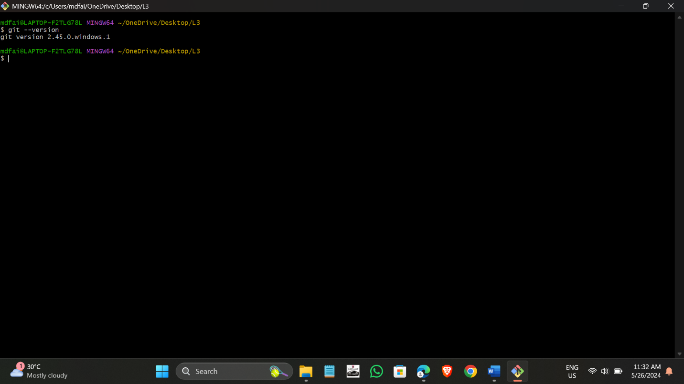

File added for the given command

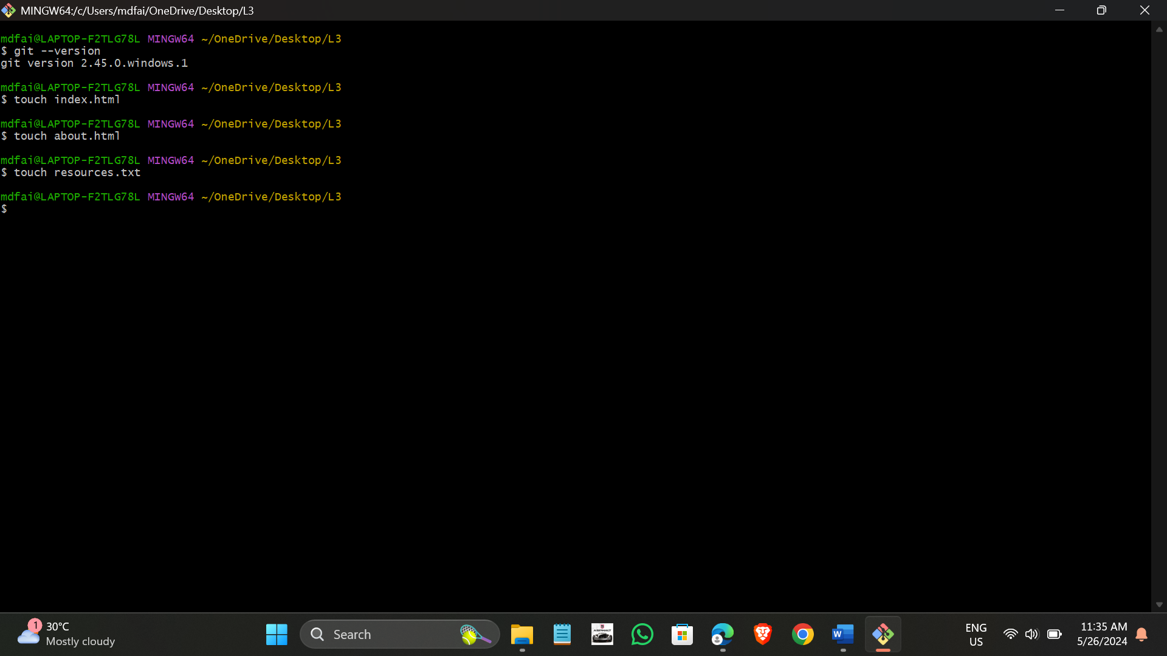

I can see these file in L3 folder

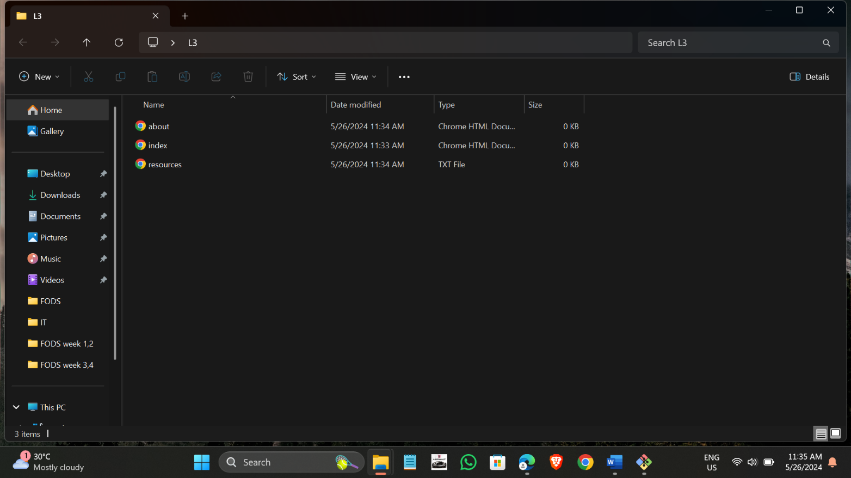

I can open index.html file write the given code save this file I can see the output

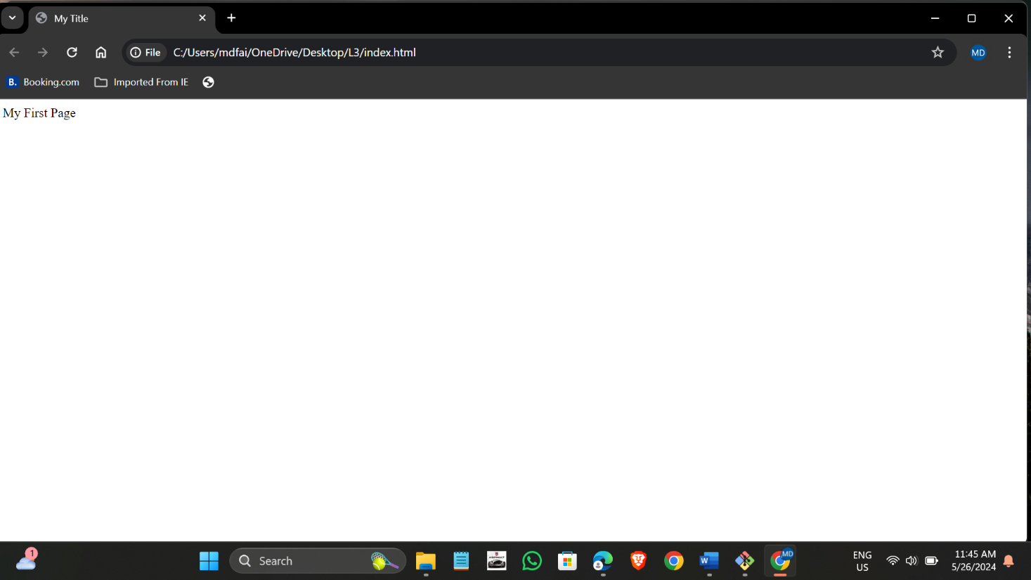

resources.txt file opened and write my name and saved this file and I can show these screen

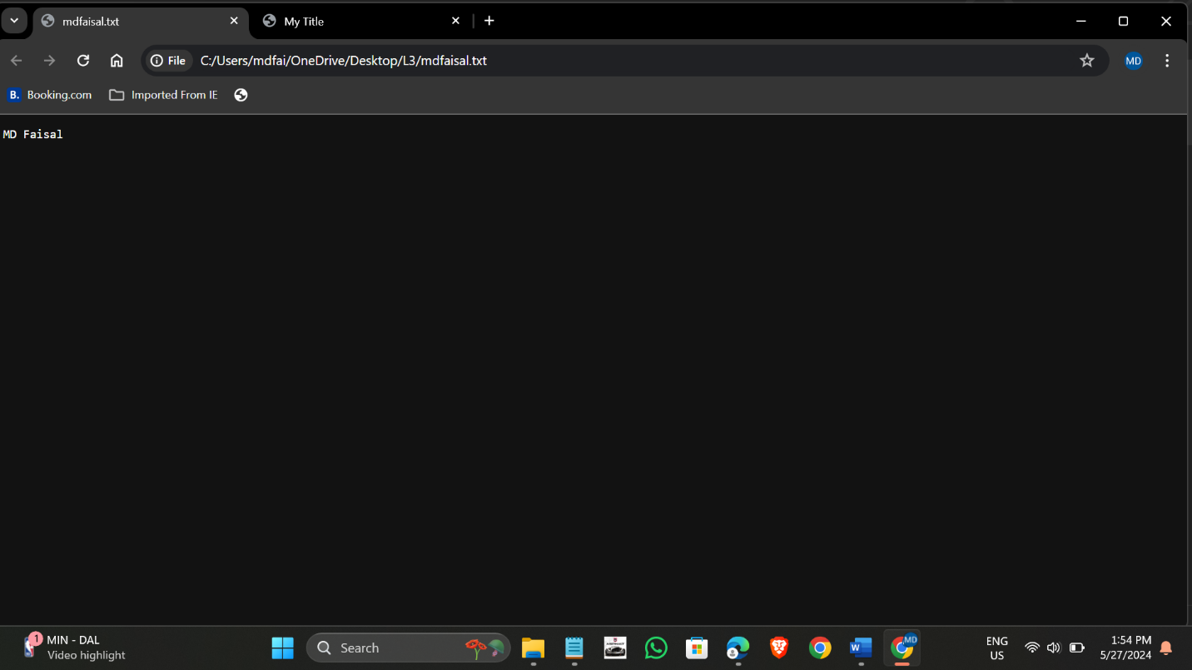

git init

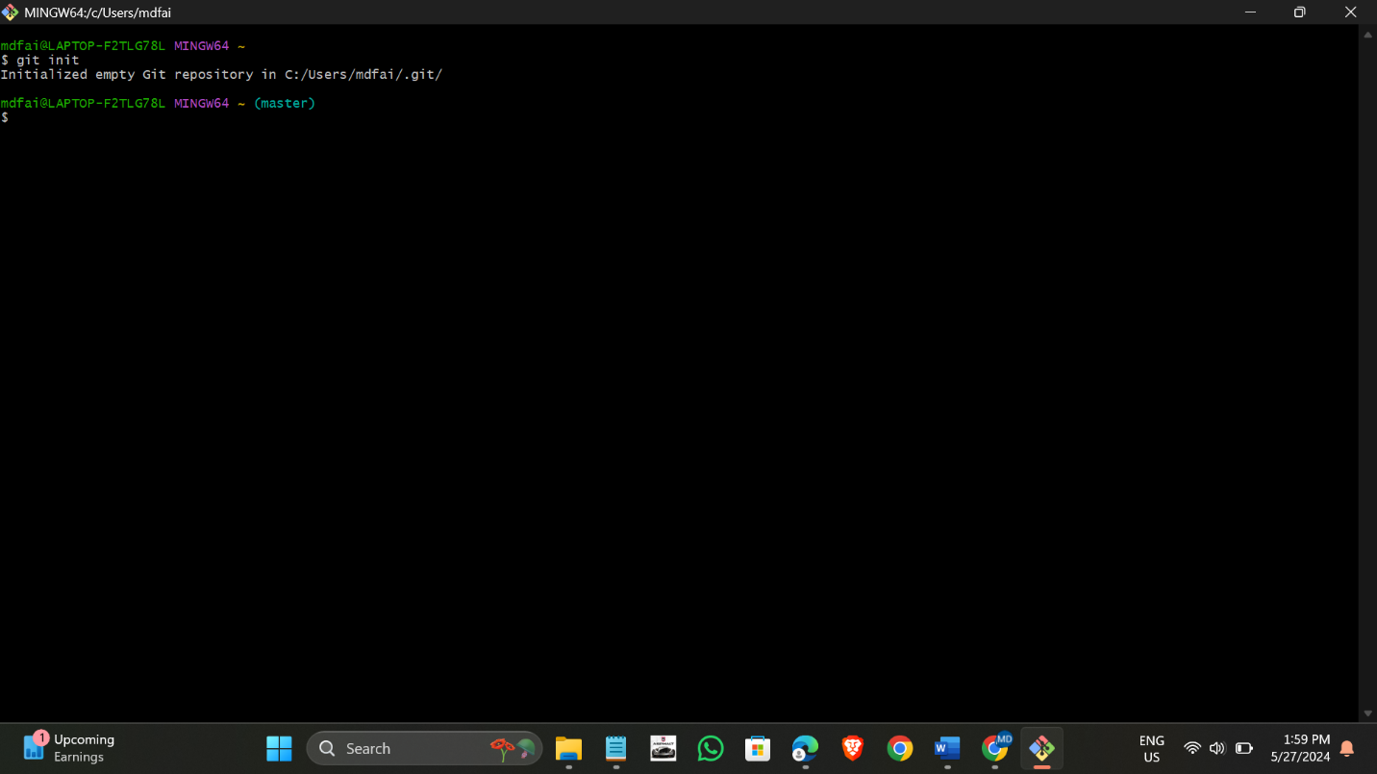

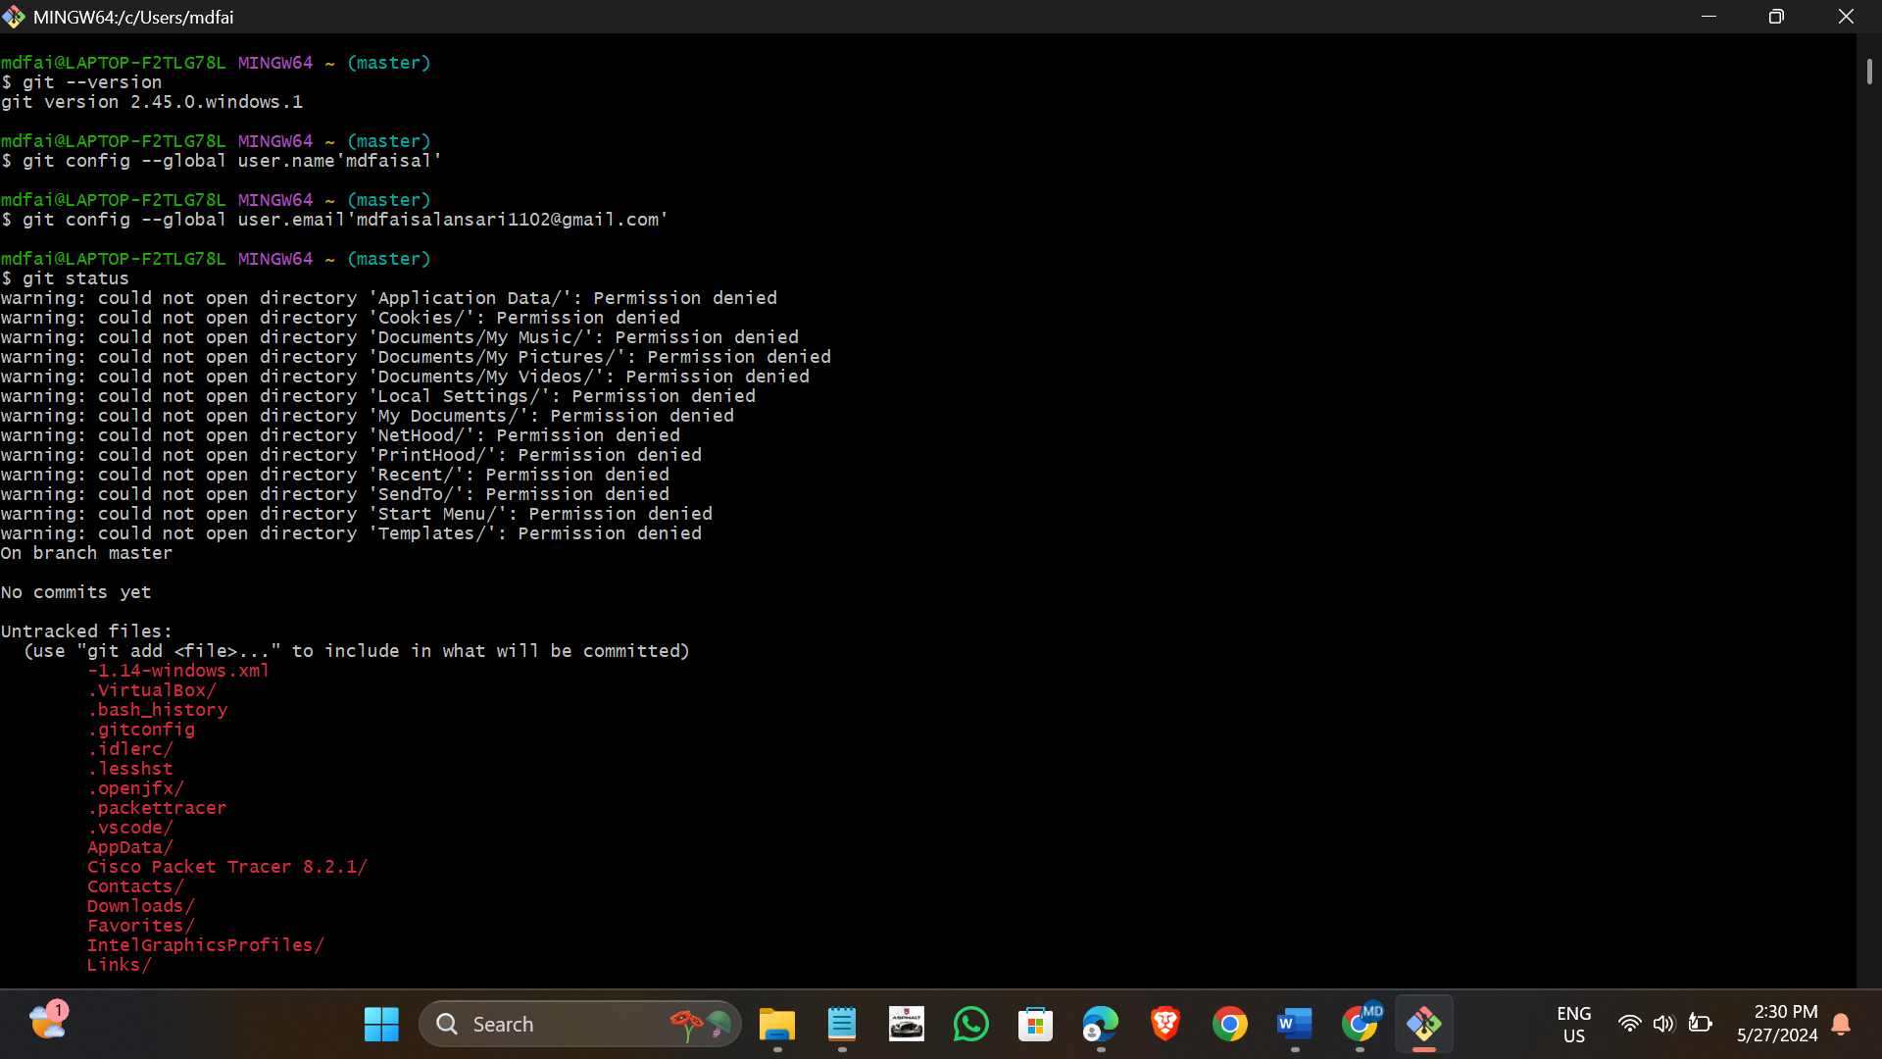

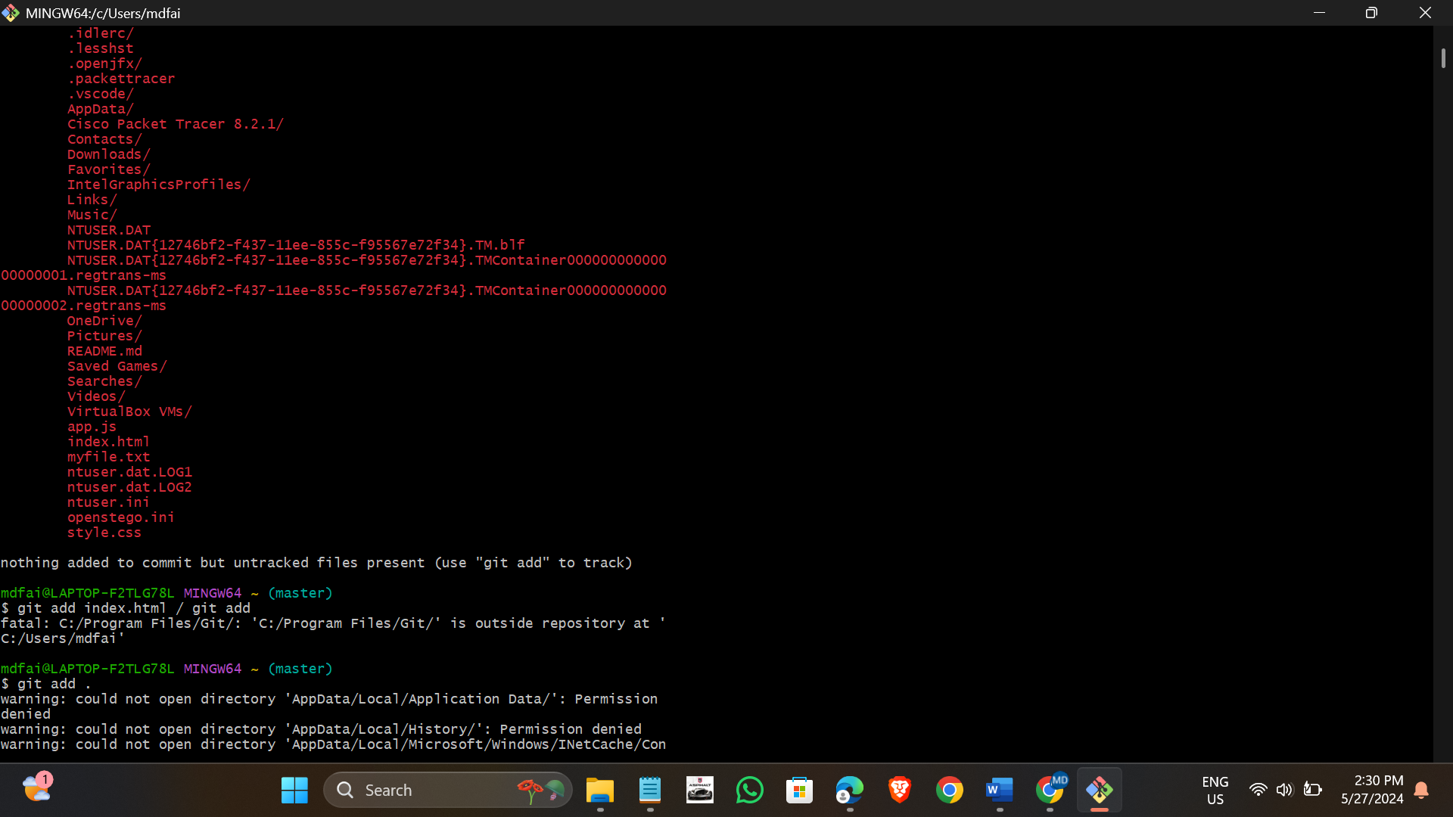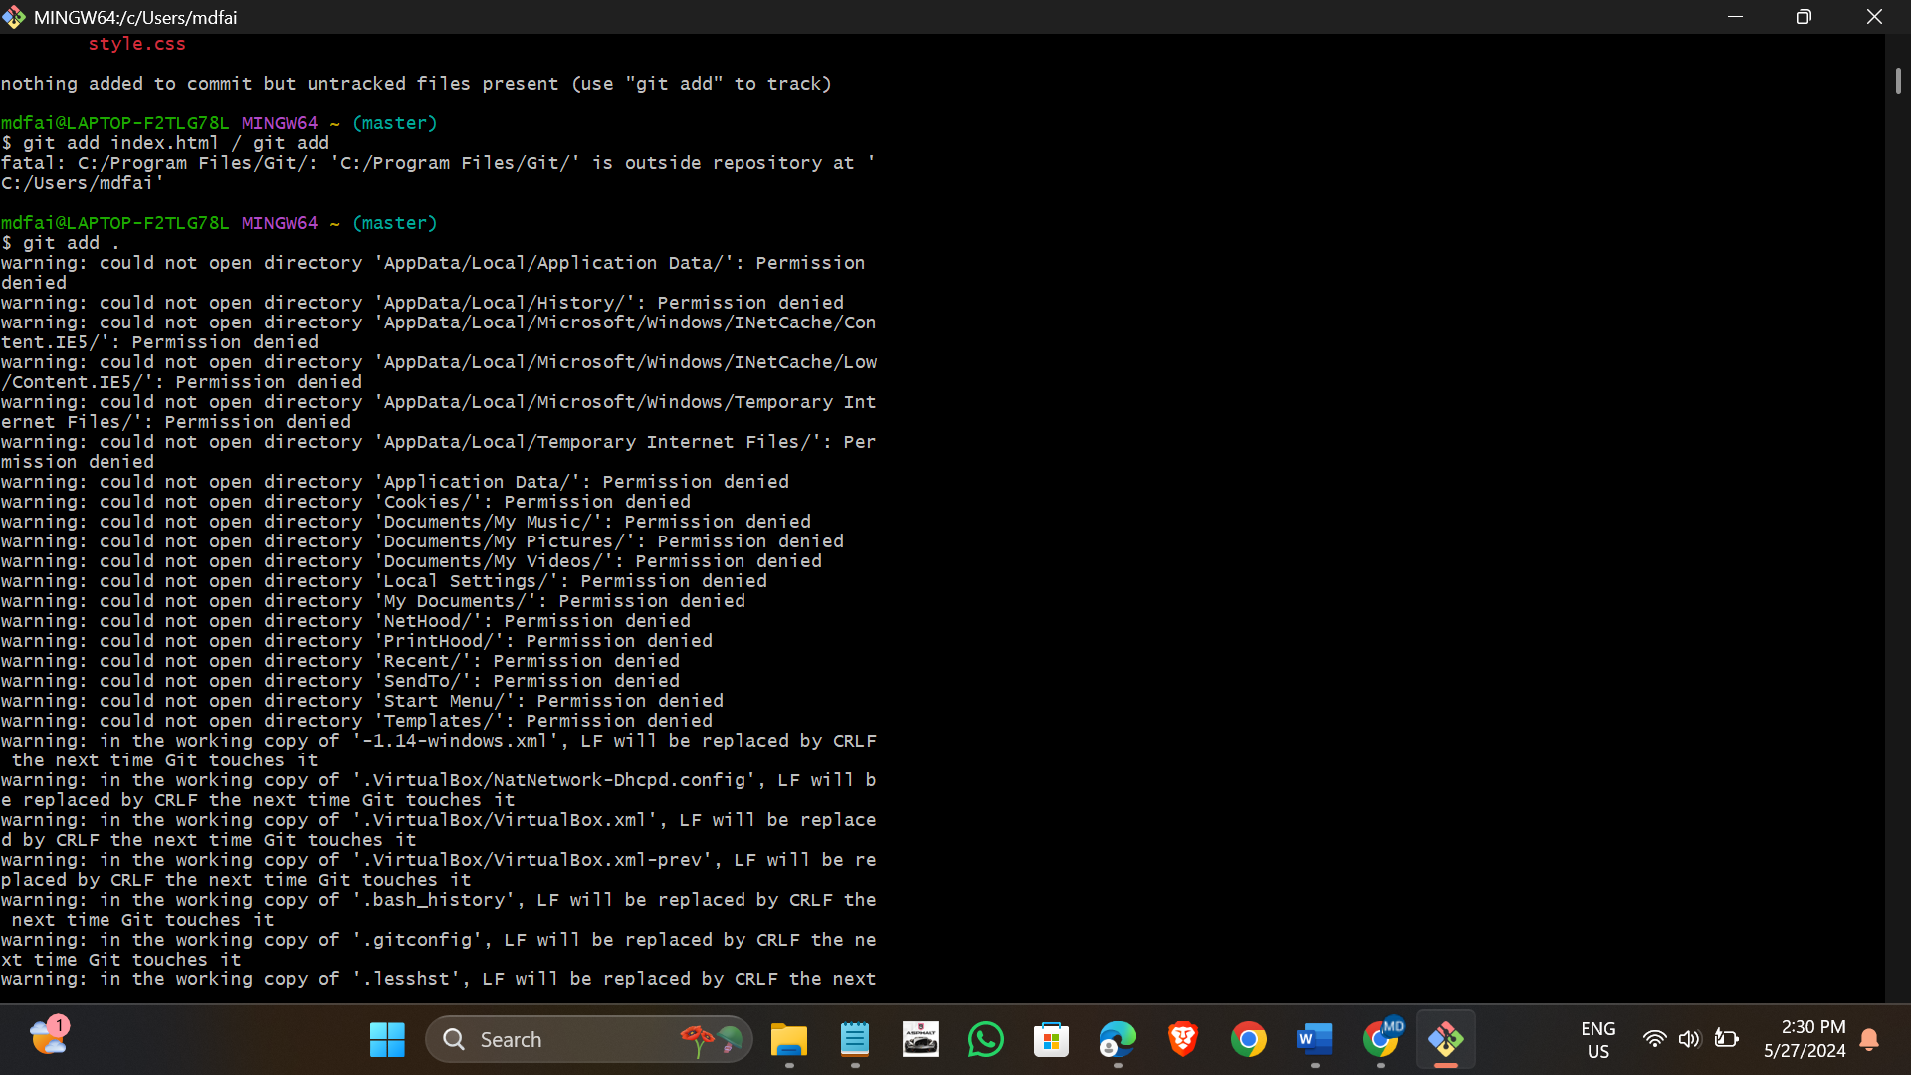

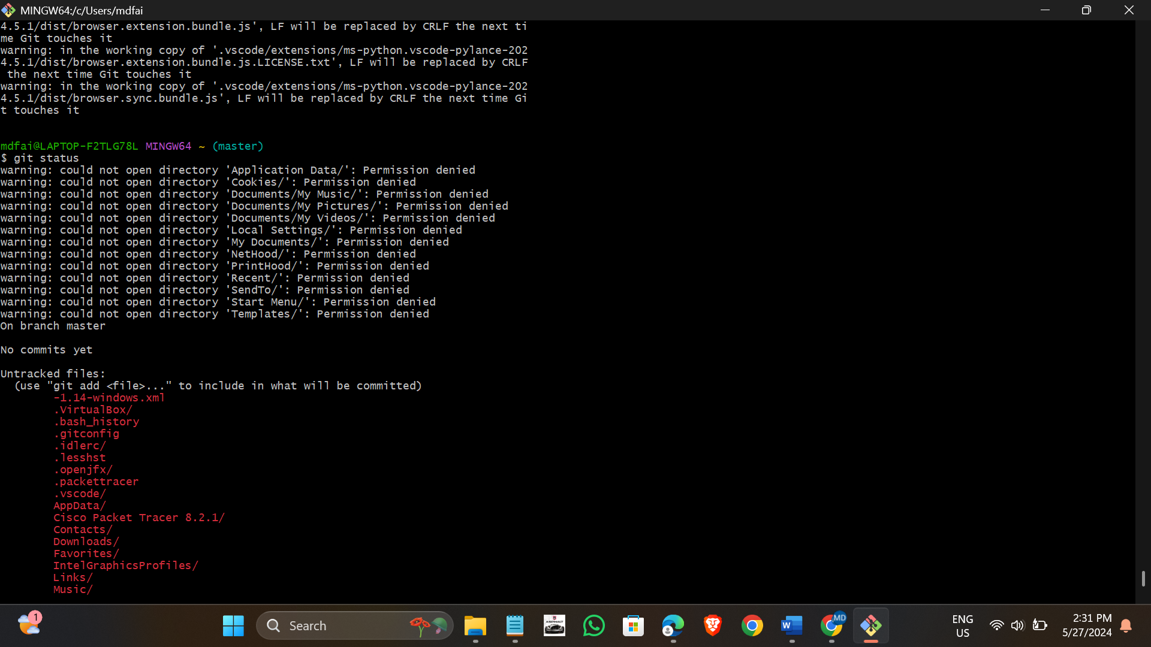

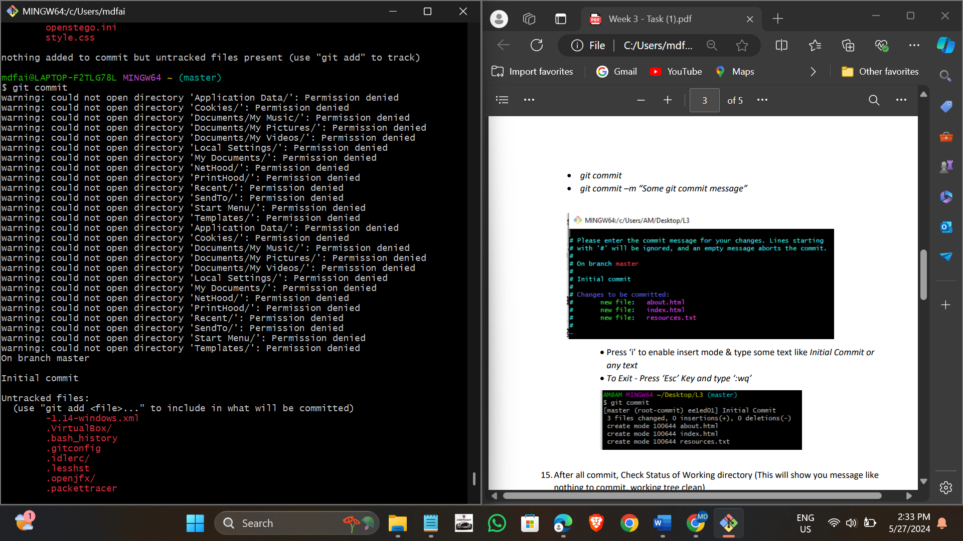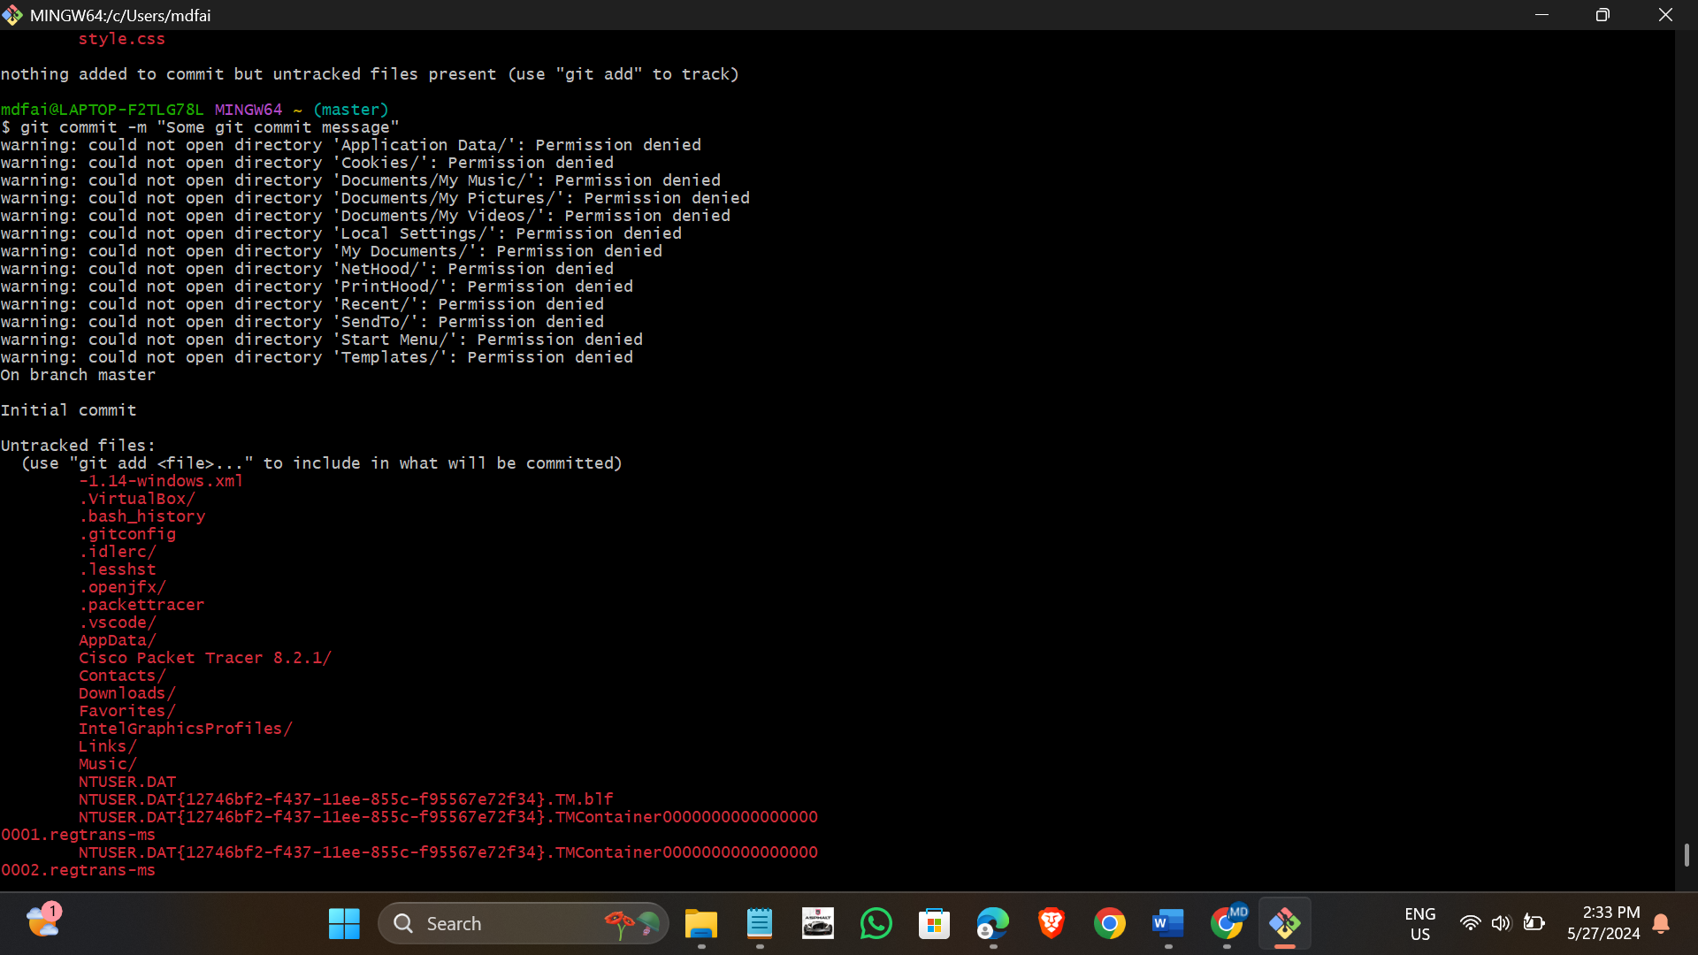

Git hub downloaded and also create account to the git hub.

